ShopNest Store -Power Bi Dashboard Report

- Question Statement: Identify and visually represent the top 10 product categories by total sales.
Top Categories item by Total Price
- This visualization highlights the top-performing product categories based on total revenue generated. The bar chart ranks categories in descending order, allowing easy identification of the most profitable segments.

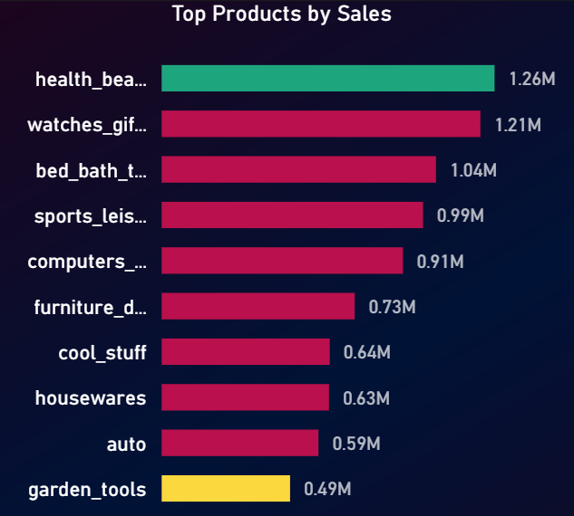

- Question Statement: - Determine the number of delayed orders in each category. An order is delayed if actual delivery date exceeds estimated delivery date.
Delayed Orders Analysis
- This chart shows the count of delayed deliveries across product categories, helping identify operational inefficiencies.

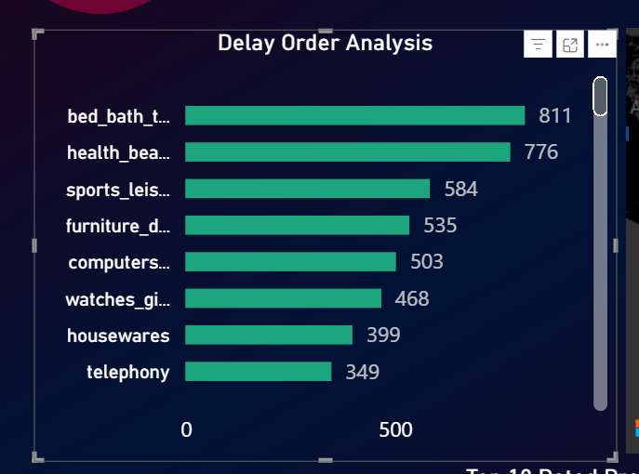

- Question Statement: - Compare delayed vs on-time orders across months.
Monthly Comparison of Delayed and On-Time Orders
- These visual compares delivery performance over time by showing delayed and on-time orders monthly.
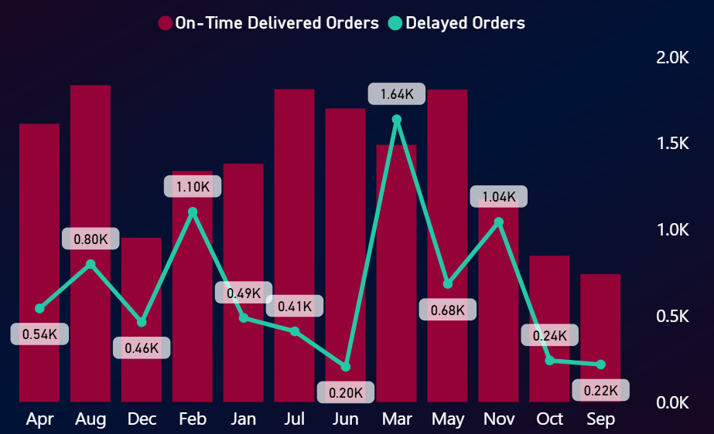
- Question Statement: - Analyse the most frequently used payment methods.
Payment Method Analysis
- This chart displays the distribution of payment methods used by customers.

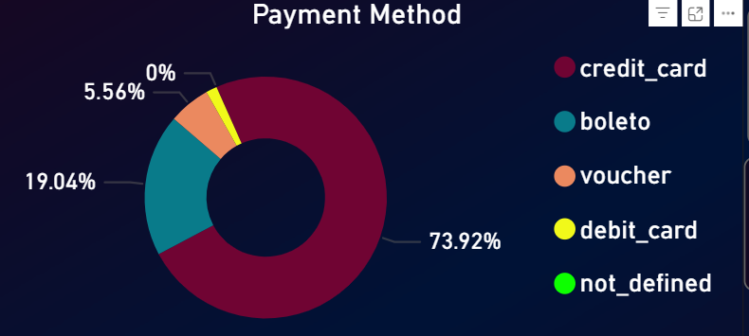

- Question Statement: - Determine the top 10 highest-rated and bottom 10 lowest-rated products.
Product Rating Analysis
- This analysis displays Top 10 and Bottom 10 rated products as per customer ratings.

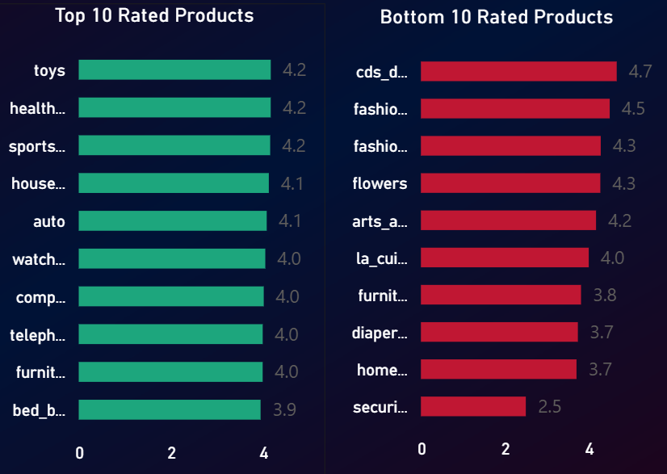

- Question Statement: - Identify states with high and low sales performance.
State-wise Sales Analysis
- This visualization shows revenue distribution across different states through a filled map.

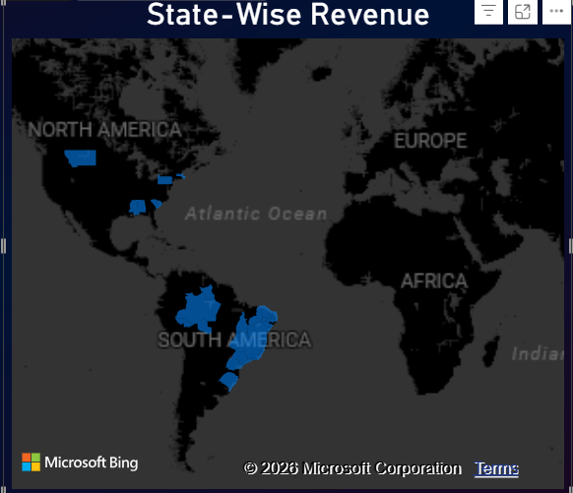

- Question Statement: - Analyse quarterly/monthly sales trends.
Seasonal Sales Patterns Monthly and Quarterly.
- This chart tracks monthly and quarterly total sales trends over time to identify seasonality.

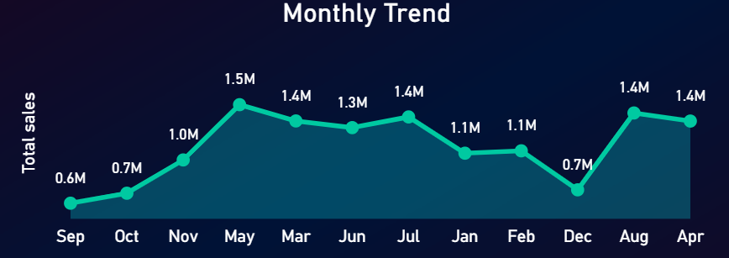
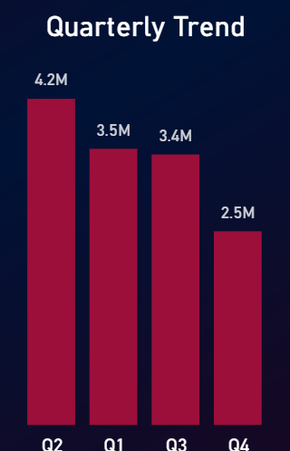

- Question Statement: - Determine total revenue and analysis yearly trends.
This visualization shows revenue growth over time(yearly)
- This visualization shows revenue growth and trend over the years.
